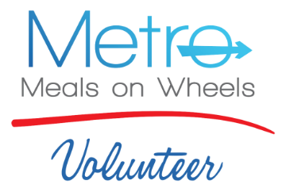

APPLICATION

Name:
(as it appears on your Driver’s License)

Address:

Phone: Email:
Date of Birth:
Social Security #:
Due to the vulnerable populations we serve, a background check is required for all volunteers. Your social security number is required and Metro Meals on Wheels covers the cost of this service.

Driver’s License #: State Issued:
Do you have current automobile insurance? Yes____ No ____
Volunteer drivers use their own car and must have their own automobile insurance. A copy
of your driver’s license will be taken during the volunteer orientation.

How did you learn about Volunteer Opportunities with Metro Meals on Wheels?

Previous Volunteer Experience:
How many hours per week would you like to volunteer?
Which days of the week are you most available?
Mon_____ Tue_____ Wed_____ Thurs_____ Fri_____

Applicant Signature Date

Send Completed Application to Maria Guzman, Volunteer Coordinator:

Email: mguzman@metromealsonwheels.net
Fax: 208-321-0032
Mail: Metro Meals on Wheels, P.O. Box 140334, Boise, ID, 83714

